To power up the INP3201 reference kit, ensure to follow the subsequent steps:

1. Place the jumper J7, J11, J13 PIN 2 and 3, J22. If powersave is enabled, place jumper J13 on PIN 1 and 2. This helps with the shutdown and wakeup of T31.
2. Type C USB power cable can be connected between J1 and the PC.
3. SW3 is the ON/OFF switch for the board.
4. T31 console can be connected on connector J9. Use the INP3000 programmer board as indicated in Figure 10.
5. If PIR is enabled, place the jumper J4. If PIR is completely disabled, remove jumper J4.

Figure 10: Console with INP3000 board

1. Connector J8 on INP3201 can also be used for T31 console instead of J9. Figure 11 depicts the connection details of the J9 connector.

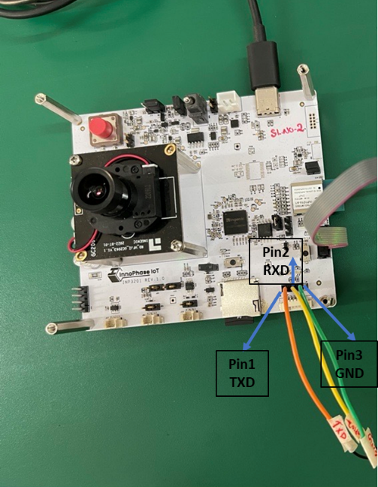

Figure 11: T31 console on J8 connector

Serial port setup for INP3201 T31 console on J9:

1. Once INP3000 is connected to the PC and the composite driver is installed, INP3000 will enumerate with the 4 COM ports.
2. Using the third COM port, a serial terminal can be opened with 115200 baud rate.
3. Once the board is powered and all the jumpers are in place, the console begins to print the T31 logs.